**Task 4. Subquery and its type:**

1. Write an SQL query to find out which customers have not placed any orders.

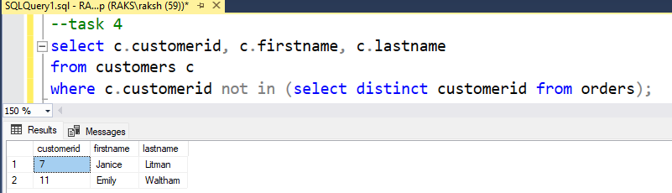

2. Write an SQL query to find the total number of products available for sale.

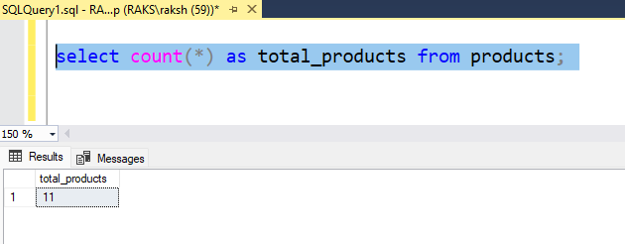

3. Write an SQL query to calculate the total revenue generated by TechShop.

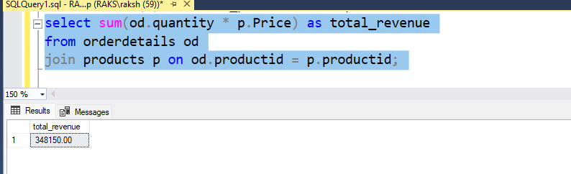

4. Write an SQL query to calculate the average quantity ordered for products in a specific category. Allow users to input the category name as a parameter.

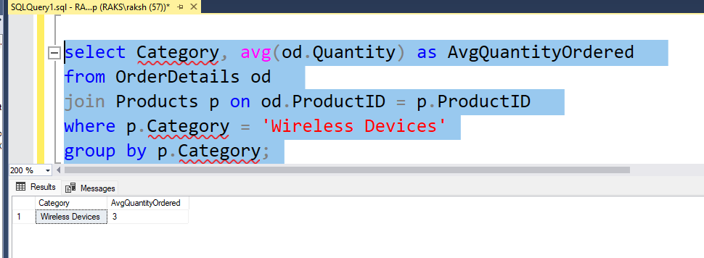

5. Write an SQL query to calculate the total revenue generated by a specific customer. Allow users to input the customer ID as a parameter.

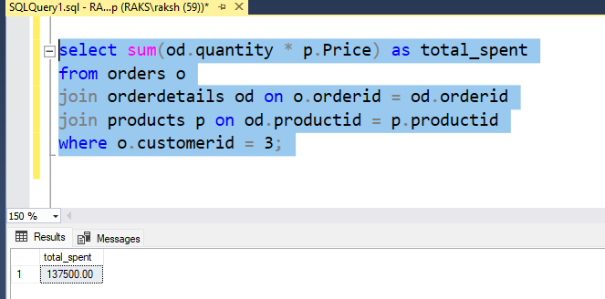

6. Write an SQL query to find the customers who have placed the most orders. List their names and the number of orders they've placed.

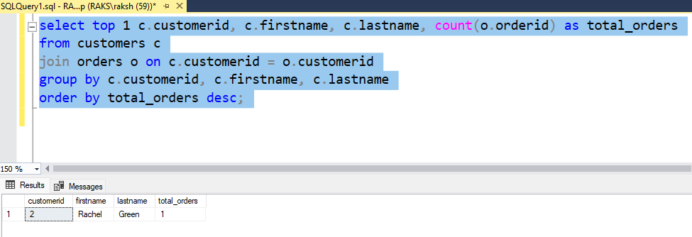

7. Write an SQL query to find the most popular product category, which is the one with the highest total quantity ordered across all orders.

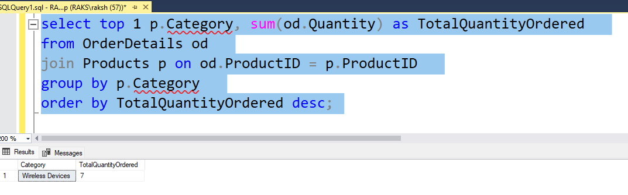

8. Write an SQL query to find the customer who has spent the most money (highest total revenue) on electronic gadgets. List their name and total spending.

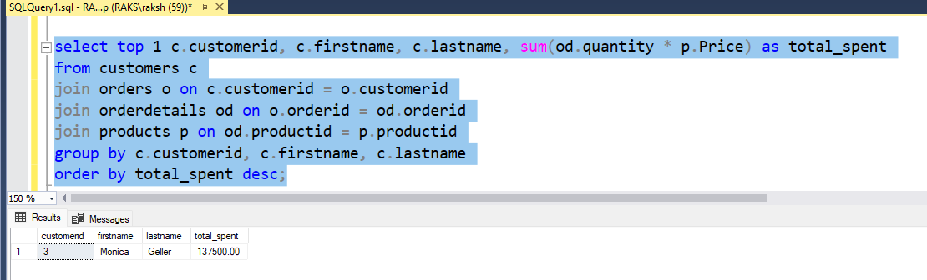

9. Write an SQL query to calculate the average order value (total revenue divided by the number of orders) for all customers.

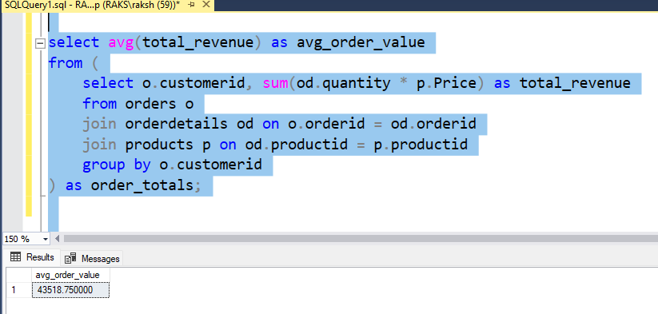

10. Write an SQL query to find the total number of orders placed by each customer and list their names along with the order count.

